Dear Mr. Ali,
I hope this message finds you in good health and high spirits.
I would like to extend my sincere appreciation to you and the entire team for the outstanding efforts and dedication demonstrated.
The feedback received from senior management was highly positive and reflects the quality of work delivered.

That said, a few adjustments have been requested, as detailed below:
Feedback | Section/Page
The icon should indicate the certificate (SIRI – ISO – SASO) | About us Page
No need to download certificates, they should just display when clicked (view the certificate only) | About us Page
Remove quick access in all pages (Hyperlinks) | All
Use UFG not UFGC or AUFGC | All
The loading icon between each page should be same as current website (UFG GIF) | All
hiring process - remove the icons | Carrer Page
in open positions, replace the icons with UFG LOGO | Carrer Page
Request test report via customer for registered clients (form will be provided) | Customer Profile
Change the videos of homepage & about UFG | Home Page
In the homepage, when clicking on any product, I can see all the thickness related to it. | Home Page
When we click the float image on the homepage, it should link to the related product in our products | Home Page
news should be a Pop Message | Home Page
CEO should be shown separately from the board members (3 grouped together) | investors page
Remove percentages in the Shareholders section | investors page
Add an extra box in the Shareholders section for "Others" | investors page
Separate reports into their own page, away from Shareholders. Hide reports and add all needed market pages like VPS | investors page
Add Riyadh and Yanbu locations in Our Location | investors page
Add contact information in the Investors page | investors page
Enhance Tadawul AUFGC section | investors page
Add a new page for executive management and hid it under investors | investors page
Allow uploading multiple images in the News section with ability to select main one picture | Media Page
Separate videos and news into different pages | Media Page
Add drop list for products in the header | Nav Bar  Nav
add the missing drop lists in the nav bar | Nav Bar  Nav
General product inquiry pricing should be shown generally without detailed info | Our Product
Thickness should be a filter; improve the look of the filters | Our Product
product page, after filtering the product, I will be able to see all configurations and thicknesses with a data sheet to download them (like the current website) | Our Product
Enhance QT Form | Our Product
Add Quality Control page , it should include a description and images to be placed under "Our Product" | Quality Page
Arabic Website version & Customer Profile, Terms & Conditions, Policy Page, Login & Registration Designs are missing. | -
how will the admin panel be? | -

For the Quality page, kindly find the details below for your review and implementation:
- Add a new page titled "Quality" – it should appear in the main navigation bar (not under “Our Product”).
- Page Sections:
  - Introduction – A description highlighting our commitment to quality and our quality policy.
  - Certificates – Displaying our official quality certificates. (to be removed from about us and added it here)
  - Quality Control Policy Document –viewable version of our internal QC policy.
  - Compliance & Standards – Similar to the existing section, with added descriptions.

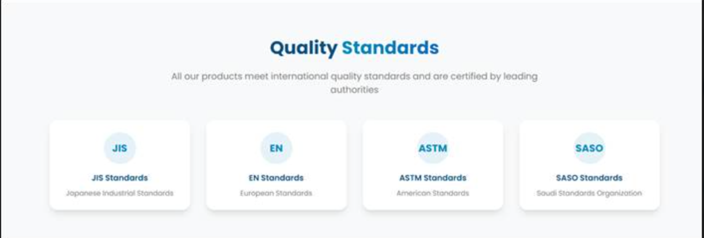

  - Quality Control Process – Same as Hiring Process section, with an image accompanying each stage: (attached)
    - Incoming Inspection
    - In-Process Inspection
    - Final Inspection

Please review and let me know if you need clarification on any point.

As agreed, we will hold a meeting to clarify all remaining details related to the Product Page.
Let me know your availability so we can schedule the meeting accordingly.

